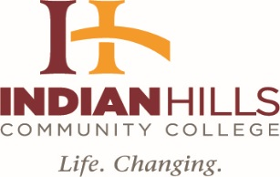

INDIAN HILLS COMMUNITY COLLEGE
BOARD OF TRUSTEES
September 9, 2019, 4:00 p.m.
Regular Meeting
Board Room, Main Campus

AGENDA

- Call Meeting to Order

- Approval of Agenda

- Approval of Minutes: August 12, 2019, Regular Board Meeting

- Unfinished Business

- Finance Report (Bill Meck, Chief Finance Officer)

  - Approval of Monthly Claims
  - Investment Policy and Resolution naming Depositories and Limits (Bill Meck)

- President Board of Trustees

- IACCT Report (Rich Gaumer)

- Human Resources Reports (Zeke Flick, Director, Human Resources)

- Personnel Report

- New Business

- President of the College

  - Facilities Report (Mr. Rick Fosdyck)
  - Quality Faculty Plan Revision (Dr. Matt Thompson, Vice President, Academic Affairs and Institutional Effectiveness)
c. Special Report: 19/FA Enrollment Report (Ms. Joni Kelley, Executive Dean, Enrollment Services & Registrar)

- Adjournment

Please go to back of Dining Room for our joint meeting with Great Prairie AEA Board

