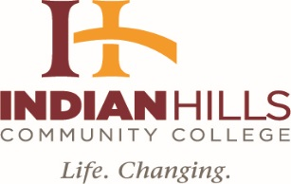

INDIAN HILLS COMMUNITY COLLEGE
BOARD OF TRUSTEES
August 12, 2019, 4:00 p.m.
Regular Meeting
Board Room, Main Campus

AGENDA

- Call Meeting to Order

- Approval of Agenda

- Approval of Minutes: July 8, 2019, Regular Board Meeting

- Unfinished Business

- Finance Report (Bill Meck, Chief Finance Officer)

  - Approval of Monthly Claims
  - FY19 Receipts and Disbursements Summary
  - FY19 Investment Report

- President Board of Trustees

- IACCT Report (Rich Gaumer)

- Human Resources Reports (Zeke Flick, Director, Human Resources)

- Personnel Report

- New Business

- President of the College

  - Facilities Report (Mr. Rick Fosdyck)
  - Resolution for Continuation of Instructional Equipment Levy (Mr. Bill Meck, Vice President, Chief Financial Officer)
c. Higher Learning Commission Update (Dr. Matt Thompson, Vice President, Academic Affairs and Institutional Effectiveness)
d. Special Report: Foundation Update (Ms. Blaire Siems, Executive Director, Foundation and Development)

- Adjournment

