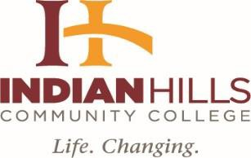

INDIAN HILLS COMMUNITY COLLEGE BOARD OF TRUSTEES
October 11, 2021, 4:00 p.m.
Regular Meeting Perkins Conference Room
Call in Number: 1.312.626.6799 Meeting ID: 931 2093 8580
https://ihcc.zoom.us/j/93120938580?pwd=OGNLTUVCVE5UV3NpL05VVkdraEVaQT09

AGENDA
- Call Meeting to Order (Roll Call)
- Approval of Agenda (Need motion and second to approve the agenda)
- Approval of Minutes: September 13, 2021, Regular Board Meeting (Need motion and second to approve the minutes)
- Unfinished Business
- Finance Report (Mr. Michael Lee, Chief Financial Officer)
  - Approval of Monthly Claims (Mr. Jerry Kirkpatrick audited bills. Need motion and second to approve)

Financial Report (Need a motion and second to approve the Financial Report) Mr. Michael Lee, Chief Financial Officer
- President Board of Trustees
  - IACCT Report (Mr. Rich Gaumer)
- Human Resources Reports (Mr. Zeke Flick, Director, Human Resources)
  - Personnel Report (Need motion and second to accept Personnel Report)
- New Business
  - Last Dollar Scholarship Programs (Dr. Jill Budde, Vice President, Learning & Engagement
- President of the College
  - Facilities Report (Dr. Brett Monaghan, Vice President, Student Development & Operations)
  - Education Program (Ms. Debora Voss, Program Director, Education)
  - Bond Referendum (Dr. Matt Thompson, President)

- Adjournment

